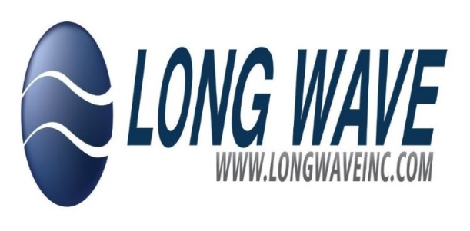

Long Wave Inc. Position Description

Position Title: Department/Location: Supervisor:
Status:
Warehouse Technician
Supply Chain/Oklahoma City, OK 73104 Director of Supply Chain
Regular/Full-Time Exempt

Job Summary:
We are seeking a detail-oriented and motivated Warehouse Technician to join our team. The ideal candidate will be responsible for supporting warehouse operations, including receiving, storing, and distributing materials and products. May also be responsible for coordination of shipments with various shipping vendors. To include quote request, quote approval, packaging, loading/unloading, shipping document preparation and shipment tracking. This role requires strong organizational skills, attention to detail, and the ability to work in a fast-paced environment.

Essential Responsibilities:

- Receive and inspect incoming shipments for accuracy and quality.
- Organize and store materials in designated areas.
- Prepare and package products for shipment.
- Maintain accurate inventory records and assist with inventory counts.
- Operate warehouse equipment, including forklifts and pallet jacks, safely and efficiently.
- Collaborate with team members to ensure smooth operations and timely order fulfillment.
- Adhere to safety protocols and maintain a clean work environment.
- Assist with other warehouse tasks as needed.
- Perform other duties as assigned

Work Conditions:

This position requires working in a warehouse setting, which may involve exposure to varying temperatures and working conditions.

Qualifications:

Minimum Requirements:

- High school diploma or equivalent.
- Previous experience in a warehouse or logistics role preferred.
- Familiarity with inventory management systems is a plus.
- Strong attention to detail and organizational skills.
- Ability to lift heavy objects up to 50lbs and perform physical tasks.
- Good communication and teamwork skills.
- Forklift certification is a plus but not required (training will be provided).

